**CIPS ANNUAL REPORT**

**2016-2017**



**National Board Chair’s Message**

Dear Members,

In the report below, I am going to provide my perspective of the past year, and discuss in detail what we have achieved so far and, the existential challenges currently facing CIPS. This report also addresses the Strategic Plan that has been proposed to the National Board for adoption.

# CIPS Mission and Vision

CIPS has been a recognized Canadian and world leader in IT professionalism, ethics, and industry governance. CIPS’ activities are mandated by statute and rooted in United Nations’ efforts to create a truly global, standards-based IT profession.

CIPS works to safeguard Canadian public interest in matters of IT and with other organizations, to promote excellence in IT through public advocacy, research, developing and maintaining a Body of Knowledge, professional certification, academic accreditation and education.

CIPS has been the respected voice of the IT profession and industry in respect of strategic, economic, entrepreneurial, R&D, employment and educational/academic activities in Canada.

# To deliver on the Mission and Vision and enhance the CIPS brand, CIPS National has diligently worked on during 2016-17, and, continues to focus on the following:

CIPS supports its members through certification and recertification activities, educational programs, career guidance, mentorship and networking opportunities and through strategic

* As stated earlier, a Strategic Plan has been presented to the board for approval. Its implementation will ensure that the challenges facing CIPS are effectively mitigated.
* Develop a 5-year plan for program development; Commission program development; Support implementation; and Monitor progress to plan, including access to relevant high quality professional development programs and services for CIPS members and other IT professionals;
* Inventory current internal and external resources;
* Assess the professional developmental needs of members;
* Conduct bi-weekly Webinars by engaging speakers who are experts in their fields. These webinars are geared for continued professional education of Members and recertification;
* Professional development programming and delivery. CIPS National will work with provinces to deliver these programs. However, if Provinces already have a program under way, our initiative is not intended to hold that up. Our programs intend to deal with local publications, research papers, practice models and career planning tools;
* Association development through resources, internal alignment, partnership/collaboration and expanding membership;
* Alliances and relationships with other professional organizations in the service of professional excellence and career satisfaction;
* Involve the younger generation into the future of CIPS. Continue and enhance plans to have regular discussions and involvement of Provincial Board and Members to enhance collaboration and enhance our priorities are based on Member needs;
* Create alignment through discussion with Provincial Boards. It is critical that outcomes be based on the needs of our key stakeholders;
* Develop a new funding model and reduce dependency on Member fees to ensure sustainability.

# Development of Infrastructure and Support System

* The Executive Council (EC) is working on defining roles and responsibilities to ensure that we are able to utilize the best volunteer talent available to us and attract new Volunteers if possible. EC is planning to expand to ensure that we have a Compliance Director, a Membership Director to help us expand the Membership and a representative to represent the Millennials/Youth
* EC has started working on programs for Youth, Women in IT, and also reviewing the needs of the existing work force, that still have many years ahead of them.
* Professional Standards Advisory Council
  + The Director of Professional Standards and Certification Council Chair are working hard to expand and attract volunteers from across the country on certification;
  + We are ensuring that various Provinces, Academia and Industry experts participate and have embarked to adding additional people to ensure fresh ideas and the upgrading of our standards;
  + The updating of the Code of Ethics (COE) and the Code of Ethics exam had stalled but we have plans and commitment to resume that in September, with a very strict deadline and get it done;
  + We are working with BCS, SFIA to develop a joint partnership that could be very beneficial for CIPS and perhaps help deal with threat of competition. BCS had plans to enter Canada themselves but set that aside to work with us. We are having similar discussions with ISACA, IRMAC and others. We have met with DPI to re-start our relationship and arrangement made years ago to provide access to our certification program to their Members.
* Partnerships and Relationships
  + CIPS is in discussions with various groups to work together on different initiatives. They include ITAC, ISACA, IRMAC and our partners overseas
  + We have already done events with ISACA and Universities and more are planned. We are also working on enhancing our relationship with both the Provincial and Federal Governments
* Projects/Events
  + CIPS has been successful in starting Students Chapters with the help of the Province and would like to replicate this across the country.
  + However besides the Webinars, we are initiating Special Interest Groups (SIGs) on topics such as Blockchain, Cyber Security, Machine Learning, Cloud, Artificial Intelligence, data Analytics. So far we have student chapters in Sheridan College, Centennial College, Conestoga College (in the technology belt) and most recently McMaster University. Due to the assistance of CIPS Ontario, these initial student chapters are based in Ontario. CIPS has now consistently put on at least 2 Webinars a month on topics listed above and has attracted top notch speakers from Canada and outside to provide value to members. Many of the CIPS Webinars that have involved global speakers on various topics such as Quantum Computing, Artificial Intelligence, Cyber Security, Machine Leaning, Cloud, Analytics, Project management, Skills Gaps, Corporate Culture impacting change management, Ethics and Integrity and more. These have been broadcast in auditoriums at Colleges and Universities. These Webinars are recorded and provided to our Members across the country. Based on feedback we have received, Members see them as great value. We are now in the process of creating a CIPS Youth Council. This will help us understand fully the needs of the millennials and the younger generation and start to address them. With Canada’s ageing population this is a very critical issue and goes to the heart of CIPS’ long term future as clearly there is a gap currently in this area
  + The same situation as the Youth is also true for women in IT. There seems to be little interest comparatively in younger women to get involved in IT. Whether this is due to lack of opportunities, lack of employer encouragement, lack of encouragement, Marketing or lack of good IT jobs or equal pay for equal work is a good question. I believe it is a combination and CIPS has an important role to play.
* Governance
  + Mahira Mohtashami has been doing a lot of work regarding on-boarding of all new Board members, so they are fully cognizant of their responsibilities as directors, not to mention their fiduciary responsibilities;
  + This exercise will assist in getting Board members more focussed on their accountabilities and deliverables.
* Membership
  + We are starting to attract membership from Universities and colleges and have created a few Student Chapters. We will be putting in a strong effort to build on these 5 and more importantly we want to see student chapters across the Country;
  + This effort has helped us attract some capable younger members with our emphasis on bringing in more women as part of “women in IT” initiative.
* Revenue Generation
  + Our plans are getting finalized for providing training programs to our Members and non-members;
  + In some cases we will partner with organizations who already have such programs in place and meet the high standards in providing professional development opportunities;
  + In some cases we will conduct half and full day training using the expertise of senior CIPS members already involved in training.
* Youth Council (in progress).

CIPS, like other non for profit Association has continued to rely on volunteers, it has had its own challenges; however we have been successful in attracting some excellent resources. We have and continue to make concerted efforts to attract a senior corporate presence as well as academia to assist us in this area and have been successful for the most part. This effort continues and we expect to bring in more volunteers from Corporations (with executives experience at the Board level as well as engage more youth including women).

Our effort at starting Student Chapters at Universities is producing excellent results and we will continue these efforts in the current year. Our objective is to have a CIPS Youth Board that will include at least 50% of women directors. To that extent we now have two very capable, Catherine Poehlman, Umme Salma, ladies who are now working with CIPS to get this initiative under way. This is a high priority for us.

This is a brief and high level update on the progress that CIPS has made thus far, and, you can expect more in the near future as things are starting to take shape.

**Challenges:**

The key challenges facing CIPS the way I see them are:

* The value and relevance of memberships
* Erosion of membership
* Aging membership
* Poor exposure to the market place
* Lack of employer recognition
* Structural complexity, lack of internal cohesiveness
* Strong competition from other associations
* Lack of volunteers
* Lack of funding to manage reasonable staff complement or to do programs
* Total dependence of Membership fees for revenues
* Volunteer burnout for those who do the work
* Lack of understanding about the fiduciary responsibilities and/or constitution
* Lack of new representation on Provincial Boards, hence lack of new ideas and tendency to get territorial
* Lack of consistent commitment or passion on part of some across all Members of the Provincial Boards
* Challenges for some Provincial Boards who do not have funds and therefore are unable to provide programs needed to attract and retain Members.
* Our ability to execute and the accountability of completing projects

The work highlighted in the earlier section of my report is designed to mitigate some of these challenges. The Strategy Plan proposed to the board too is designed to further strengthen the organization and CIPS’ brand. However, the challenge posed by the move by Alberta undermines all the progress made so far and creates a significant distraction by diverting the attention that we need to provide to the aforementioned challenges.



Bashir Fancy, I.S.P., (ret.)

Chairman & CEO

Canadian Information Processing Society (CIPS)

[bsfancy@rogers.com](mailto:bsfancy@rogers.com)

**Governance Structure**

Elect

Supports

Governs

Elect

Manages

Recommends standards

Manages

Regulates

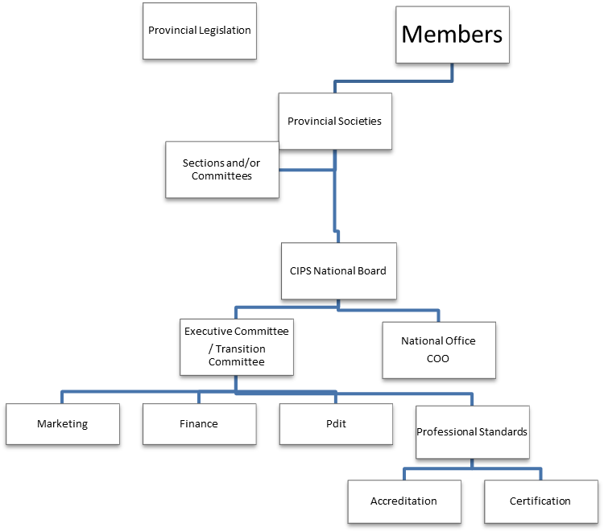

The above diagram is a reflection of the governance model as defined in the CIPS constitution and bylaws and has been in effect since 2008, with one exception. In September 2014 the Transition Committee was formed to temporarily take on the role of the Executive Council.

**CIPS National Board (as of September 2017)**

The National Board is the governing body of CIPS.  The Board is composed of CIPS Provincial and National members who represent both certified and non-certified members. No changes have been made to this governing body, although there have been Director retirements and newly nominated directors coming on board throughout the year.

To contact a member of the Board, please send your message to [info@cips.ca](mailto:info@cips.ca).

|  |  |  |  |  |
| --- | --- | --- | --- | --- |
|  | **Chair** Bashir Fancy, I.S.P., (ret.) |  |  | **Director-at-Large** Yolande Chan |
|  | **Director-at-Large**  Jude Pillainayagam, I.S.P. |  |  | **Ex-Officio** Mary Jean Kucerak  COO |
|  | **British Columbia & Yukon Territories** Ralph Roberts |  |  | **Alberta & North West Territories** Derek Burt, I.S.P., ITCP |
|  | **Saskatchewan** Shaun Herron, I.S.P., ITCP |  |  | **Manitoba** Gary Craven, I.S.P., ITCP |
|  | **Ontario** Mahira Mohtashami |  |  | **Newfoundland and Labrador/Nunavut**  Sean Callahan |
|  | **New Brunswick**  Sandy Fadale |  |  | **Nova Scotia** Lem Murphy I.S.P., ITCP |
|  | **Prince Edward Island** Vacant |  |  | **Quebec**  Alain Desjardins |

## Professional Standards Report



First my thanks to predecessor, Brenda Byers, I.S.P., ITCP and chair of the Executive Council, Bashir Fancy, for assisting in my transition into the role of Director of Professional Standards towards the end of 2016.

The many hours spent immersing myself into CIPS National standards efforts is a testament to the depth and dynamic work by all those past and present dedicated CIPS members to our national and international professionalism.  Remarkable is an understatement to describe the credibility that our professional designation provincially, nationally and internationally garners from corporations, educational institutions, government and worldwide IT professional associations.

I would be remiss not to mention that four new members joined the Certification Council subcommittees.  Our chair, Mukesh Kashyap is focused on onboarding of highly qualified individuals for both the Education and Experience subcommittees.  Given recent acceleration of new I.S.P. applicants, additions to these subcommittees are key priorities.  Additionally a review has started on updating and modernizing the review process which will improve the assessment process and reduce application processing times.

Executive Council has been building out a holistic strategic plan with national standards, certification and accreditation at its heart.  As such National Standards form part of and included in all planning and execution of CIPS National Board directions.

Sincerely,

Ken Metcalfe, I.S.P., CCP, ITCP/IP3P

CIPS Director of Professional Standards, 2017

[metcalfe@cips.ca](mailto:metcalfe@cips.ca)

### Director of Finance Report



As I reflect back over the past 6 months since my start with CIPS, I would like to highlight the following for consideration by the Members and the Board of Directors:

1. Membership: Over the past several years Provincial Funding to the national body is declining, and the pace of such decline has increased in recent years:

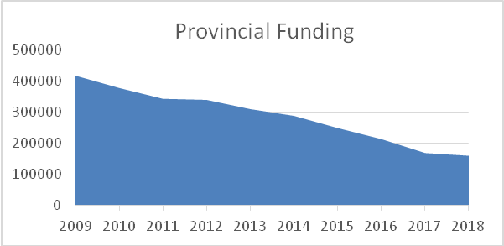

This is a direct consequence of reduction in membership all across Canada. This trend is expected to continue all through Canada, except for Saskatchewan. The decline is expected to be more severe for Alberta compared to the rest of Canada (see note 3 below). On a positive note:

* There is healthy increase in membership applications for Saskatchewan. We are projecting growth of 40% in membership for the Province for 2017-18.
* Further, the count of students has been increasing steadily over the past two years. The National Board along with the provincial bodies need to undertake measures to convert the graduate students to full membership status.

1. Value to Members: A significant portion of the annual expense has been to support administrative needs of the organization. In several meetings of the board this sentiment was echoed through calls for more value add services for members. Based on the new Strategy proposed by the Chair a number of initiatives have been planned for 2017-18 and funds have been provisioned accordingly.
2. Alberta’s proposal to take over the administration and certification activities for members from that province has raised a lot of discussion over the past several months. I have not been provided any business case supporting why this move is good for their members or how it serves the interests of the CIPS brand nationally. If Alberta were to proceed regardless, it is likely to create two layers of administrative support (one for Alberta, and, one at the National level to maintain the support to all other provinces), and, possibly result in duplicated costs. Alberta’s membership projections for the next year, by Alberta board’s own estimates, are expected to decline by 20-30%. This is in contrast with the numbers for the rest of Canada. This is also at odds given the decline in revenues, increasing competition from other professional bodies, and at a time when the strategy and new initiatives by National call for more cohesion. Furthermore, the constitutionality of this move itself is under review. This matter is now in front of the National board for discussion, and, the foregoing is to provide context.

Sincerely,

### Vikas Kulkarni

Director of Finance

viswaksh@hotmail.com

### **Accredited Programs:**

**CIPS accreditation helps:**

* Raise the profile of IT courses;
* Fast-tracks graduates of accredited programs to the AITP, I.S.P. and ITCP designations;
* Exposes students to the perspectives of CIPS members on opportunities in the IT industry and the importance of professionalism, ethics and ongoing professional development.

The following programs were re-accredited by CIPS:

#### Colleges

**British Columbia Institute of Technology**

Computer Systems Technology

Computer Information Technology

Bachelor of Technology - Computer Systems

**Higher Colleges**

Bachelor of Applied Science in Business Information Technology

Bachelor of Applied Science in Computer Network Technology

Bachelor of Applied Science in Information Technology (Business and Information Systems)

Bachelor of Applied Bachelor of Applied Science in Information Management

Science in Information Technology (Information Administration)

Bachelor of Applied Science in Information Technology  (Interactive Multimedia)

Bachelor of Applied Science in Information Technology (Information Systems Security)

Bachelor of Applied Science in Information Technology (Network Engineering)

Bachelor of Applied Science in Information Technology (Software Engineering)

Bachelor of Applied Science in Information Technology (Web Development)

Bachelor of Applied Science in Information Systems (with 2 majors :  Business Solutions, Security and Forensics)

Bachelor of Applied Science in Information Technology (with 4 majors: Applications Development, Instructional Technology and Training Management, Interactive Multimedia, Networking)

**Red River College**

Business Information Technology (BIT)

**Saskatchewan Polytechnic Saskatoon**

Computer Systems Technology

**New AITP, I.S.P./ITCP Designation Holders (as of July 1, 2016 to June 30, 2017)**



Holders of the AITP designation have demonstrated that they have the educational requirements for the I.S.P. designation and are working to obtain the required work experience for full certification status.

**Congratulations to the following AITP Members:**

Olabode Adegbayike, AITP

Tushar Aggarwal, AITP

Vipul Arora, AITP

Liam Corrigan, AITP

Jasdeep Dhother, AITP

Colin Domansky, AITP

Amna Gulraiz, AITP

Andrew Hilderman, AITP

Taarush Jain, AITP

Albin Job, AITP

Navid Alvee Khan, AITP

Devon Kupiec, AITP

Nathan MacNeil, AITP

Haroon Monsif, AITP

Rukshar Patel, AITP

Dipen Shah, AITP

Ishaan Srivastava, AITP

Kamran Syed, AITP

Atchyuth Vaddineni, AITP

Li Xu, AITP

Bryan Yip, AITP

Dawit Yosef, AITP

Jacky Zhang, AITP



Holders of the I.S.P. and ITCP designations have demonstrated that they possess the education and experience to practice to the highest standards in their field.

**Congratulations to the following Certified Members:**

Adewole Adetayo, I.S.P.

Jandy J. Agoy, I.S.P.

Fahd Ahmed, I.S.P.

Richard Al, I.S.P.

Salem Alrowaihi, I.S.P., ITCP

Lisa Barnes, I.S.P.

Abid Bashir, I.S.P., ITCP

Steven Beres, I.S.P.

Frances Briones, I.S.P., ITCP

Gerhard Diedericks, I.S.P.

Wasif Durani, I.S.P., ITCP

Abayomi Fagbebe, I.S.P.

Andrew Grimo, I.S.P.

Mohammad Hussein Hamad, I.S.P.

Jakkree Kanharat, I.S.P.

Gina Manulak-Mould, I.S.P.

Edward Michael Markowski, I.S.P.

Karyn Mart, I.S.P.

Abraham Megidish, I.S.P., ITCP

Stephen Nolan, I.S.P.

Adesola A Olayinka, ITCP

Andrew Palmer, I.S.P.

Jim Pelley, I.S.P.

Chad Reid, I.S.P.

Kamran Rizvi, I.S.P., ITCP

Luiz Rodrigues, I.S.P.

Inoka Samarakkody, I.S.P.

Justin Stade, I.S.P.

Anthony Truong, I.S.P.

Liang Yan, I.S.P.

Wayne Yu, I.S.P.

**Financial Statements**

**Canadian Information Processing Society: *Consolidated Financial Statements, June 30, 2016.*** The 2015-2016 Audited Financial Statements are available in a separate document from the National web site.

**National Services**

The CIPS national service delivery is an integral part of the Executive Council and ensures the daily administration of the association is successful. Resources are located in Mississauga, Ontario and provide support for the National Board, Standing Committees , Councils and Provincial Societies. These roles include the coordination of all volunteers from across Canada to ensure service delivery is completed in a timely and efficient way.



Mary Jean Kucerak

Chief Operating Officer



Jonathan Elias

Contractor

**Contact:**

CIPS - National  
60 Bristol Rd E

Unit 8, #324  
Mississauga, Ontario L4Z 3K8

Telephone: (905) 602-1370  
Toll Free: 1-877-ASK-CIPS *(275-2477)*Fax: (905) 602-7884  
E-mail: [info@cips.ca](mailto:info@cips.ca)

Website: [www.cips.ca](http://www.cips.ca)